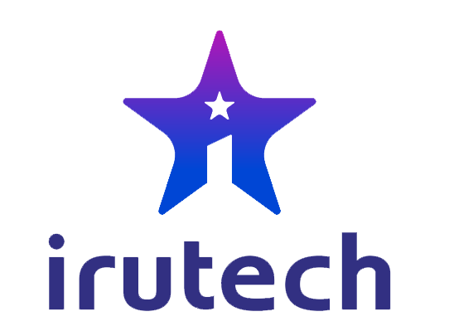

Irutech Company Profile

[www.irutechnology.com](http://www.irutechnology.com)

COMPANY PROFILE

**YOUR OFFSHORE SOFTWARE DEVELOPMENT PARTNER**

  

Address Telephone Email

Thapagaun, Baneshwor +977-9851060005 info@irutechnology.com

Kathmandu, Nepal +977-9801060005

**About Us**

Irutech is an emerging software company in Nepal providing world-class quality software development for its clients. We product intelligent and powerful software which completely maneuvers our client’s job proficiently. We are mote committed to continuously improvise our intellect and expertise so that we can accomplish our success through the elevated performance and quality. We believe to listen, research and understand the requirements of each individual business.

Irutech’s Commencement, proven, demonstrate unique products, techniques and capabilities that uniquely distinguish us from other software development providers. We are already specialized in developing varies automated solutions in the field of Schools, Colleges, Consultancies, Data Management, Medical, Reality Shows, etc. that is tailored to utilized the international standard.

**Who We Are?**

We (Software team) is specialized in producing software to assist you to operate your entire industry smoothly for maximum output. Our development team consists of well experience and qualified system analysist, application developers, solution developers, database administrators, programmers and quality testers. Implementing creative ideas along with cutting-edge tools and technologies in each phases of development, we can assure that the system output will be top-rated and friendly to our client.

**What We Do?**

* Software Development
* Web Application Development
* Mobile App Development (Android / iOS)
* Database Design
* Software Testing
* IT Training
* Technology Consultant
* Project Planning and Management
* Prototyping and R&D
* Domain Registration and Hosting

**Our Values**

* Quality
* Creative
* Innovation
* Customer Satisfaction
* Technology
* Cooperative
* Trust

**Services**

|  |  |
| --- | --- |
| Software Development | Database Design |
| Irutech is an experienced software development company providing offshore software development services to its clients. We offer user friendly and robust applications in combination with any modern database system. The applications can be totally standalone running in a single machine, network solutions or internet connected application.  Our services includes:   * Enterprise Applications * Desktop Applications * Web Applications * API and Addins * Mobile and Tablet Apps (Android /iOS) * Software Maintenance | We offer different types of database development and design services. We are experienced in standard database technologies like Oracle, Microsoft SQL, MySQL, PostgreSQL and different Big Data and Cloud data base systems. We maintain best practices in planning, designing, developing, maintaining and monitoring system when needed.  Services includes:   * Database Design * Database Development * Database Analysis and Reporting * Data Security * Database Migration * Database Performance Tuning |

|  |  |
| --- | --- |
| **Software Testing** | **Technology Consultant** |
| Irutech assures clients to deliver the best applications or systems by providing quality assurance. For which we offer different types of testing services from creating test cases to test report generation. Our team is highly experienced in functional and nonfunctional testing. We practice the best test planning, test case design, test environment, test execution, reporting etc.  Our services includes:   * Black box and White box Test * Performance Test * Compatibility Test * Load Test * Integration Test | Irutech provides high-end and mission critical enterprise solutions meeting all your requirements to achieve your ultimate business goals. We offer consultancy services that span the entire IT lifecycle, from business process re-engineering to software system design, development and implementation.We are tailored to satisfy your business requirements.  Our services includes:   * Enterprise Solutions * Application Development Services * Mobile Development Services * Technical and Management Training * Project Management |

|  |  |
| --- | --- |
| **Mobile App Development** | **VA/PT** |
| We/ our team is one of the experienced mobile apps developer, that designs and build an app that will live up to the vision of a client enabling them to leverage maximum productivity. We are currently developing various business solutions for mobile devices. We ensure to give our client more flexibility in their path ahead.  Platforms:   * Android * iOS * Windows | Vulnerability Assessment (VA) and Penetration Testing (PT) are the combination of two different security services serving their own area over network and application. With the available latest VA tools we try to find the flaws in the system that might cause damang. Our expertise team exploits the flaws that are identified and suggest necessary measures to get rid of it. In other word it shows how damaging a flaw could be in real attack. Here at Irutech, We offer both VA & PT services to our onshore and offshore clients. |

|  |  |
| --- | --- |
| **Social Media Marketting** | **Server Setup/Configuration** |
| Our social media marketing experience at various of our existing clients extents all of the major social networks, including: Facebook, Instagram, Twitter, Youtube etc. Our main focus working on social media will be our customers brand. We not just post a post, we do with logic and strategy in mind. Here we deals with various offers:   * Content Creation * Regular Posting * Hashtag Outreach * Audience Analysis * Graphic Design * Lead Generation * Branding | Inorder to achieve high performance from an application, a Server and well server setup s the most. Keeping this in mind, we at Irutech provide server setup and maintenance services to our clients. This includes:   * Windows Server * Linux Server * Cloud Server * Nginx * AWS etc. |

**Technologies**

Following are the list of tools and technologies we use for our various software development projects, though we are not limited to it.

|  |  |
| --- | --- |
| **Programming / Development** | **Database** |
| * C#, ASP.net * JAVA * Android SDK * Swift for iOS * JQuery, Boot-strap, Google API, JaveScript * Python * PHP, Laravel * Git, Visio, Eclipse, Android Studio | * Microsoft SQL Server * Oracle Database Server * MySQL * PostgreSQL * MongoDB * DynamoDB |

|  |  |
| --- | --- |
| **Reporting** | **Project Management** |
| * iReport * Flot | * Scrum * Jira * Trello |

**How we work**

There are various methodologies in a software development life cycle. Among them we follow agile methodology focusion on scrum framework for our software development. We include and follow test driven development along with continuous integration among differerent modules.